National Friendly AGM Questions

- Since the news of the cancellation of the surplus has there been an increase in the number of exits above the normal?

The answer is yes, there has been an increase in the number of exits since the surplus distribution was cancelled. Lapses (including transfers to Death Benefit Only status) have run at approximately 3% per year for a number of years. The lapse rate tends to increase as the average age of members in this section increases. In 2022 however we saw a total lapse rate of approximately 8%, so yes, there has been an increase, which is likely, at least in part, to be related to the removal of the surplus distribution. As we said at the time, however, it wasn’t possible to justify keeping the surplus distribution in place, given that these surpluses effectively had to be subsidised by other members.

(b) What is the membership of this section as at 31st December 2022?

Here are the figures, for end 2021 as well as end 2022:

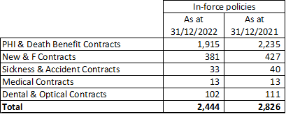

This shows a reduction in the numbers in force over 2022 book of approximately 14%, which is mostly a result of lapses, but note that over a third of these were deaths, given the high average age of these members.

- My Health Cover premium increased substantially this year. I appreciate this is based on claims experience, but it was much higher than comparable health insurers. Is Nat Friendly at a disadvantage
We are obliged to review our premiums on the 1st of January each year, consistent with any changes which our reinsurer requires based upon past claims experience and inflationary increases. This year (2023) we were one of the first to review our premiums. Other insurers have since reviewed their premiums with increases of up to 40% being reported.
- Since National Friendly has come under Alliance Health is it accepted by all health providers in the UK, please

This question was answered in Graham Singleton’s presentation when he announced our new Private Medical Claims Administrator, Healix Health, appointed from 25 September 2023. They have arrangements with all major UK hospital groups.

